jUDDI 3.0
User Guide
ASF-JUDDI-USRGUIDE-20/10/09

Contents
Table of Contents
Contents 2
About This Guide 4
What This Guide Contains 4
Audience 4
Prerequisites 4
Organization 4
Documentation Conventions 4
Additional Documentation 5
Contacting Us 5
License 5
UDDI Registry 6
Introduction to UDDI 6
UDDI Registry 6
Getting Started 8
What should I download? 8
Using the JAR 8
Using the WAR file 8
Using the Tomcat Bundle 8
Using jUDDI the Web Services 9
Authentication 11
Introduction 11
JUDDI Authentication 12
XMLDocAuthentication 12
CryptedXMLDocAuthentication 12
JBoss Authentication 13
Database Setup 14
Derby Out-of-the-box 14
Switch to MySQL 15
Switch to Postgres 16
Switch to <other db> 17
Root Seed Data 18
Introduction 18
Seed Data Files 18
Tokens in the Seed Data 20
Custom Seed Data 20
jUDDI Configuration 21
Introduction 21
Startup 21
Subscription 21
Using the jUDDI-Client 22
Introduction 22
Configuration 22
JAX-WS Transport 22
RMI Transport 23
InVM Transport 23
Dependencies 23
Sample Code 24
UDDI Annotations 25
Introduction 25
@UDDIService 25
@UDDIServiceBinding 25
Subscriptions 26
Introduction 26
Two node example setup: Sales and Marketing 26
Deploy the HelloSales Service 29
Synchronous notifications 34
Subscription Listener 35
Administration 36
Introduction 36
Changing the listener port 36
References 37
Index 38

About This Guide

What This Guide Contains
The User Guide document describes use of jUDDI – installation and setup.

Audience
This guide is most relevant to engineers who are responsible for setting up jUDDI 3.0 installations.

Prerequisites
None.

Organization
This guide contains the following chapters:
- Chapter 1, Setup
- Chapter 2, Authentication

Documentation Conventions
The following conventions are used in this guide:

Convention | Description
Italic | In paragraph text, italic identifies the titles of documents that are being referenced. When used in conjunction with the Code text described below, italics identify a variable that should be replaced by the user with an actual value.
Bold | Emphasizes items of particular importance.
Code | Text that represents programming code.
Function | Function | A path to a function or dialog box within an interface. For example, “Select File | Open.” indicates that you should select the Open function from the File menu.
( ) and | | Parentheses enclose optional items in command syntax. The vertical bar separates syntax items in a list of choices. For example, any of the following three items can be entered in this syntax:  persistPolicy (Never | OnTimer | OnUpdate | NoMoreOftenThan)
Note:  Caution: | A note highlights important supplemental information.  A caution highlights procedures or information that is necessary to avoid damage to equipment, damage to software, loss of data, or invalid test results.

Table 1 Formatting Conventions

Additional Documentation
None on the subject.

Contacting Us
Email: juddi-user@ws.apache.org

License
Copyright 2001-2009 The Apache Software Foundation.
Licensed under the Apache License, Version 2.0 (the "License");
you may not use this file except in compliance with the License.
You may obtain a copy of the License at
http://www.apache.org/licenses/LICENSE-2.0
Unless required by applicable law or agreed to in writing, software
distributed under the License is distributed on an "AS IS" BASIS,
WITHOUT WARRANTIES OR CONDITIONS OF ANY KIND, either express or implied.
See the License for the specific language governing permissions and
limitations under the License.

UDDI Registry

Introduction to UDDI
The Universal Description, Discovery and Integration (UDDI) protocol is one of the major building blocks required for successful Web services. UDDI creates a standard interoperable platform that enables companies and applications to quickly, easily, and dynamically find and use Web services over the Internet. UDDI also allows operational registries to be maintained for different purposes in different contexts. UDDI is a cross-industry effort driven by major platform and software providers, as well as marketplace operators and e-business leaders within the OASIS standards consortium. UDDI has gone through 3 revisions and the latest version is 3.0.2. Additional information regarding UDDI can be found at http://uddi.xml.org/ [UDDI].

UDDI Registry
The UDDI Registry implements the UDDI specification. UDDI is a Web-based distributed directory that enables businesses to list themselves on the Internet and discover each other, similar to a traditional phone book's yellow and white pages. The UDDI registry is both a white pages business directory and a technical specifications library. The Registry is designed to store information about Businesses and Services and it holds references to detailed documentation.

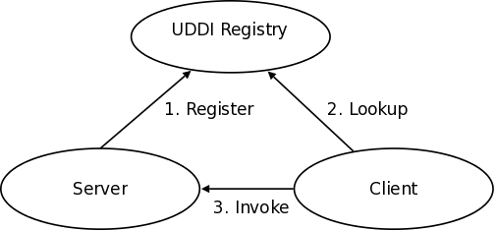
Figure 1.1 Invocation pattern using the UDDI Registry.
A business publishes services to the UDDI registry. A client looks up the service in the registry and receives servicebinding information. The client then uses the binding information to invoke the service. The UDDI APIs are SOAP based for interoperability reasons. The UDDI v3 specification defines 9 APIs:
- UDDI_Security_PortType, defines the API to obtain a security token. With a valid security token a publisher can publish to the registry. A security token can be used for the entire session.
- UDDI_Publication_PortType, defines the API to publish business and service information to the UDDI registry.
- UDDI_Inquiry_PortType, defines the API to query the UDDI registry. Typically this API does not require a security token.
- UDDI_CustodyTransfer_PortType, this API can be used to transfer the custody of a business from one UDDI node to another.
- UDDI_Subscription_PortType, defines the API to register for updates on a particular business of service.
- UDDI_SubscriptionListener_PortType, defines the API a client must implement to recieve subscription notifications from a UDDI node.
- UDDI_Replication_PortType, defines the API to replicate registry data between UDDI nodes.
- UDDI_ValueSetValidation_PortType, by nodes to allow external providers of value set validation. Web services to assess whether keyedReferences or keyedReferenceGroups are valid.
- UDDI_ValueSetCaching_PortType, UDDI nodes may perform validation of publisher references themselves using the cached values obtained from such a Web service

Getting Started

What should I download?
The jUDDI server deploys as a WebARchive (war) named juddiv3.war. Within jUDDI, there are three downloadable files (juddi-core.jar, juddi.war, and juddi-tomcat.zip). You should determine which one to use depending on what level of integration you want with your application and your platform / server choices.
JUDDI also ships with client side code, the juddi-client.jar. The jUDDI server depends on the juddi-client.jar in situations where one server communicates to another server. In this setup one server acts as a client to the other server. The juddi-client.

Using the JAR
The juddi-core module produces a JAR which contains the jUDDI source and a jUDDI persistence.xml configuration. jUDDI's persistence is being actively tested with both OpenJPA and with Hibernate. If you are going to use only the JAR, you would need to directly insert objects into jUDDI through the database back end or persistence layer, or configure your own Web Service provider with the provided WSDL files and classes.

Using the WAR file
As with the JAR, you need to make a decision on what framework you would like to use when building the WAR. jUDDI's architecture supports any JAX-WS compliant WS stack (Axis, CXF, etc). The jUDDI 3.0.GA release ships with CXF in the Tomcat bundle, but any docs or descriptors to support other WS stacks would be welcome contributions. Simply copy the WAR to the deploy folder of your server (this release has been tested under Apache Tomcat 6.0.20), start your server, and follow the directions under “using jUDDI as a Web Service”.

Using the Tomcat Bundle

The jUDDI Tomcat bundle packages up the jUDDI WAR, Apache Derby, and a few necessary configuration files and provides the user with a pre-configured jUDDI instance. By default, Hibernate is used as the persistence layer and CXF is used as a Web Service framework. To get started using the Tomcat bundle, unzip the juddi-tomcat-bundle.zip, and start Tomcat :

% cd apache-tomcat-6.0.20/bin
% ./startup.sh

It is suggested that you use JDK 1.6 with the Tomcat 6 bundle. On Mac OS X you can either change your JAVA_HOME settings or use /Applications/Utilities/Java Preferences.app to change your current JDK.
Once the server is up and running can make sure the root data was properly installed by browsing to
http://localhost:8080/juddiv3
You should see the screen show in Figure 2.1.
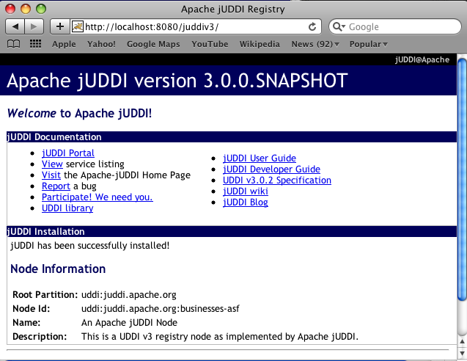
Figure 2.1. jUDDI welcome page.

Using jUDDI the Web Services
Once the jUDDI server is started, you can inspect the UDDI WebService API by browsing to
http://localhost:8080/juddiv3/services
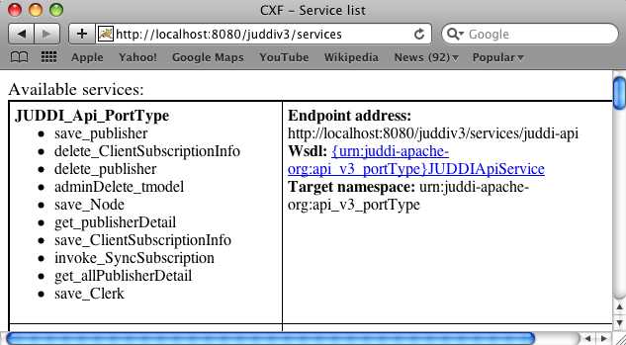
You should see an overview of all the Services and their WSDLs.
Figure 2.2. UDDI Services Overview

The services page shows you the available endpoints and methods available. Using any SOAP client, you should be able to send some sample requests to jUDDI to test:

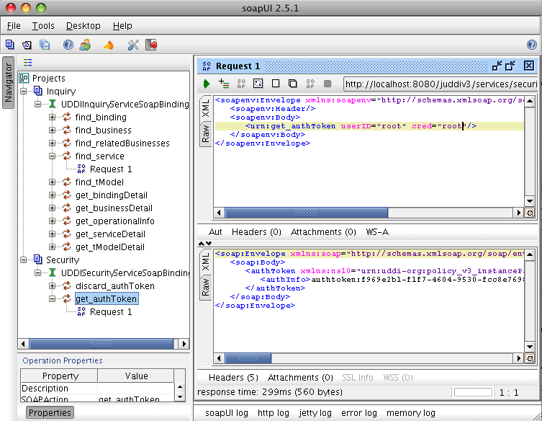
Figure 2.3. Getting an authToken using SoapUI.

Authentication

Introduction
In order to enforce proper write access to jUDDI, each request to jUDDI needs a valid authToken. Note that read access is not restricted and therefore queries into the registries are not restricted.
To obtain a valid authToken a getAuthToken() request must be made, where a GetAuthToken object is passed. On the GetAuthToken object a userid and credential (password) needs to be set.

org.uddi.api_v3.GetAuthToken ga = new org.uddi.api_v3.GetAuthToken();
ga.setUserID(pubId);
ga.setCred("");

org.uddi.api_v3.AuthToken token = securityService.getAuthToken(ga);

The property juddi.auth in the juddi.properties configuration file can be used to configure how jUDDI is going to check the credentials passed in on the GetAuthToken request. By default jUDDI uses the JUDDIAuthenticator implementation. You can provide your own authentication implementation or use any of the ones mention below. The implementation needs to implement the org.apache.juddi.auth.v3.Authenticator interface, and juddi.auth property should refer to the implementation class.
There are two phases involved in Authentication. The authenticate phase and the identify phase. Both of these phases are represented by a method in the Authenticator interface.
The authenticate phase occurs during the GetAuthToken request as described above. The goal of this phase is to turn a user id and credentials into a valid publisher id. The publisher id (referred to as the “authorized name” in UDDI terminology) is the value that assigns ownership within UDDI. Whenever a new entity is created, it must be tagged with ownership by the authorized name of the publisher. The value of the publisher id can be completely transparent to jUDDI – the only requirement is that one exists to assign to new entities. Thus, the authenticate phase must return a non-null publisher id. Upon completion of the GetAuthToken request, an authentication token is issued to the caller.
In subsequent calls to the UDDI API that require authentication, the token issued from the GetAuthToken request must be provided. This leads to the next phase of jUDDI authentication – the identify phase.
The identify phase is responsible for turning the authentication token (or the publisher id associated with that authentication token) into a valid UddiEntityPublisher object. The UddiEntityPublisher object contains all the properties necessary to handle ownership of UDDI entities. Thus, the token (or publisher id) is used to “identify” the publisher.
The two phases provide compliance with the UDDI authentication structure and grant flexibility for users that wish to provide their own authentication mechanism. Handling of credentials and publisher properties can be done entirely outside of jUDDI. However, jUDDI provides the Publisher entity, which is a sub-class of UddiEntityPublisher, to persist publisher properties within jUDDI. This is used in the default authentication and is the subject of the next section.

JUDDI Authentication
The default authentication mechanism provided by jUDDI is the JUDDIAuthenticator. The authenticate phase of the JUDDIAuthenticator simply checks to see if the user id passed in has an associated record in the Publisher table. No credentials checks are made. If -during authentication- the publisher does not exist, it the publisher is added on the fly.
Do not use jUDDI authentication is production.
The identify phase uses the publisher id to retreive the Publisher record and return it. All necessary publisher properties are populated as Publisher inherits from UddiEntityPublisher.
juddi.auth = org.apache.juddi.v3.auth.JUDDIAuthentication

XMLDocAuthentication
The XMLDocAuthentication implementation needs a XML file on the classpath. The juddi.properties file would need to look like
juddi.auth = org.apache.juddi.v3.auth.XMLDocAuthentication
juddi.usersfile = juddi-users.xml
where the name of the xml can be provided but it defaults to juddi-users.xml, and the content of the file would looks something like
<?xml version="1.0" encoding="UTF-8" standalone="yes"?>
<juddi-users>
<user userid="anou_mana" password="password" />
<user userid="bozo" password="clown" />
<user userid="sviens" password="password" />
</juddi-users>
The authenticate phase checks that the user id and password match a value in the XML file. The identify phase simply uses the user id to populate a new UddiEntityPublisher.

CryptedXMLDocAuthentication
The CryptedXMLDocAuthentication implementation is similar to the XMLDocAuthentication implementation, but the passwords are encrypted
juddi.auth = org.apache.juddi.v3.auth.CryptedXMLDocAuthentication
juddi.usersfile = juddi-users-encrypted.xml
juddi.cryptor = org.apache.juddi.cryptor.DefaultCryptor
where the name user credential file is juddi-users-encrypted.xml, and the content of the file would looks something like
<?xml version="1.0" encoding="UTF-8" standalone="yes"?>
<juddi-users>
<user userid="anou_mana" password="+j/kXkZJftwTFTBH6Cf6IQ=="/>
<user userid="bozo" password="Na2Ait+2aW0="/>
<user userid="sviens" password="+j/kXkZJftwTFTBH6Cf6IQ=="/>
</juddi-users>
The DefaultCryptor implementation uses BEWithMD5AndDES and Base64 to encrypt the passwords. Note that the code in the AuthenticatorTest can be used to learn more about how to use this Authenticator implementation. You can plugin your own encryption algorithm by implementing the org.apache.juddi.cryptor.Cryptor interface and referencing your implementation class in the juddi.cryptor property.
The authenticate phase checks that the user id and password match a value in the XML file. The identify phase simply uses the user id to populate a new UddiEntityPublisher.

JBoss Authentication
Finally is it possible to hook up to third party credential stores. If for example jUDDI is deployed to the JBoss Application server it is possible to hook up to it's authentication machinery. The JBossAuthenticator class is provided in the docs/examples/auth directory. This class enables juddi deployments on JBoss use a server security domain to authenticate users.
To use this class you must add the following properties to the juddi.properties file:
juddi.auth=org.apache.juddi.v3.auth.JBossAuthenticator
juddi.securityDomain=java:/jaas/other
The juddi.auth property plugs the JbossAuthenticator class into the juddi the Authenticator framework. The juddi.sercuity.domain, configures the JBossAuthenticator class where it can lookup the application server's security domain, which it will use to perform the authentication. Note that JBoss creates one security domain for each application policy element on the $JBOSS_HOME/server/default/conf/login-config.xml file, which gets bound to the server JNDI tree with name java:/jaas/<application-policy-name>. If a lookup refers to a non existent application policy it defaults to a policy named other.

Database Setup

Derby Out-of-the-box
By default jUDDI uses an embedded Derby database. This allows us to build a downloadable distribution that works out-of-the-box, without having to do any database setup work. We recommend switching to an enterprise-level database before going to production. JUDDI uses the Java Persistence API (JPA) in the back end and we've tested with both OpenJPA and Hibernate. To configure which JPA provider you want to use, you will need to edit the configuration in the persistence.xml. This file can be found in the
juddi.war/WEB-INF/classes/META-INF/persistence.xml
For Hibernate the content of this file looks like
<?xml version="1.0" encoding="UTF-8"?>
<persistence xmlns="http://java.sun.com/xml/ns/persistence"
xmlns:xsi="http://www.w3.org/2001/XMLSchema-instance"
xsi:schemaLocation="http://java.sun.com/xml/ns/persistence http://java.sun.com/xml/ns/persistence/persistence_1_0.xsd"
version="1.0">
<persistence-unit name="juddiDatabase" transaction-type="RESOURCE_LOCAL">
<provider>org.hibernate.ejb.HibernatePersistence</provider>
<jta-data-source>java:comp/env/jdbc/JuddiDS</jta-data-source>
<!-- entity classes -->
<class>org.apache.juddi.model.Address</class>
<class>org.apache.juddi.model.AddressLine</class>
<class>org.apache.juddi.model.AuthToken</class>
<class>org.apache.juddi.model.BindingCategoryBag</class>
<class>org.apache.juddi.model.BindingDescr</class>
<class>org.apache.juddi.model.BindingTemplate</class>
<class>org.apache.juddi.model.BusinessCategoryBag</class>
<class>org.apache.juddi.model.BusinessDescr</class>
<class>org.apache.juddi.model.BusinessEntity</class>
<class>org.apache.juddi.model.BusinessIdentifier</class>
<class>org.apache.juddi.model.BusinessName</class>
<class>org.apache.juddi.model.BusinessService</class>
<class>org.apache.juddi.model.CategoryBag</class>
<class>org.apache.juddi.model.Contact</class>
<class>org.apache.juddi.model.ContactDescr</class>
<class>org.apache.juddi.model.DiscoveryUrl</class>
<class>org.apache.juddi.model.Email</class>
<class>org.apache.juddi.model.InstanceDetailsDescr</class>
<class>org.apache.juddi.model.InstanceDetailsDocDescr</class>
<class>org.apache.juddi.model.KeyedReference</class>
<class>org.apache.juddi.model.KeyedReferenceGroup</class>
<class>org.apache.juddi.model.OverviewDoc</class>
<class>org.apache.juddi.model.OverviewDocDescr</class>
<class>org.apache.juddi.model.PersonName</class>
<class>org.apache.juddi.model.Phone</class>
<class>org.apache.juddi.model.Publisher</class>
<class>org.apache.juddi.model.PublisherAssertion</class>
<class>org.apache.juddi.model.PublisherAssertionId</class>
<class>org.apache.juddi.model.ServiceCategoryBag</class>
<class>org.apache.juddi.model.ServiceDescr</class>
<class>org.apache.juddi.model.ServiceName</class>
<class>org.apache.juddi.model.ServiceProjection</class>
<class>org.apache.juddi.model.Subscription</class>
<class>org.apache.juddi.model.SubscriptionChunkToken</class>
<class>org.apache.juddi.model.SubscriptionMatch</class>
<class>org.apache.juddi.model.Tmodel</class>
<class>org.apache.juddi.model.TmodelCategoryBag</class>
<class>org.apache.juddi.model.TmodelDescr</class>
<class>org.apache.juddi.model.TmodelIdentifier</class>
<class>org.apache.juddi.model.TmodelInstanceInfo</class>
<class>org.apache.juddi.model.TmodelInstanceInfoDescr</class>
<class>org.apache.juddi.model.TransferToken</class>
<class>org.apache.juddi.model.TransferTokenKey</class>
<class>org.apache.juddi.model.UddiEntity</class>
<class>org.apache.juddi.model.UddiEntityPublisher</class>

<properties>
<property name="hibernate.archive.autodetection" value="class"/>
<property name="hibernate.hbm2ddl.auto" value="update"/>
<property name="hibernate.show_sql" value="false"/>
<property name="hibernate.dialect" value="org.hibernate.dialect.DerbyDialect"/>
</properties>
</persistence-unit>
</persistence>
The persistence.xml reference a datasource “java:comp/env/jdbc/JuddiDS”. Datasource deployment is Application Server specific. If you are using Tomcat, then the datasource is defined in
juddi/META-INF/context.xml
which by default looks like
<?xml version="1.0" encoding="UTF-8"?>

<Context>
<WatchedResource>WEB-INF/web.xml</WatchedResource>
<!-- -->
<Resource name="jdbc/JuddiDS" auth="Container"
type="javax.sql.DataSource" username="" password=""
driverClassName="org.apache.derby.jdbc.EmbeddedDriver"
url="jdbc:derby:juddi-derby-test-db;create=true"
maxActive="8"
/>
</Context>

Switch to MySQL
To switch over to MySQL you need to add the mysql driver (i.e. The mysql-connector-java-5.1.6.jar) to the classpath and you will need to edit the persistence.xml
<property name="hibernate.dialect" value="org.hibernate.dialect.MySQLDialect"/>
and the datasource. For tomcat you the context.xml should look something like
<?xml version="1.0" encoding="UTF-8"?>
<Context>
<WatchedResource>WEB-INF/web.xml</WatchedResource>
<Resource name="jdbc/JuddiDS" auth="Container"
type="javax.sql.DataSource" username="root" password=""
driverClassName="com.mysql.jdbc.Driver"
url="jdbc:mysql://localhost:3306/juddiv3"
maxActive="8"/>
</Context>
WARNING: Tomcat copies the context.xml to conf/CATALINA/localhost/juddiv3.xml, and if you update the context.xml it may not update this copy. You should siumply delete the juddiv3.xml file after updating the context.xml.
To create a MySQL database name juddiv3 use
mysql> create database juddiv3
and finally you probably want to switch to a user which is a bit less potent then 'root'.

Switch to Postgres
This was written from a JBoss - jUDDI perspective. Non-JBoss-users may have to tweak this a little bit, but for the most part, the files and information needed is here.
Logged in as postgres user, access psql:
# psql

postgres= CREATE USER juddi with PASSWORD 'password';
postgres= CREATE DATABASE juddi;
postgres= GRANT ALL PRIVILEGES ON DATABASE juddi to juddi;
Note, for this example, my database is called juddi, as is the user who has full privileges to the database. The user 'juddi' has a password set to 'password'.
<datasources>
<local-tx-datasource>
<jndi-name>JuddiDS</jndi-name>
<connection-url>jdbc:postgresql://localhost:5432/juddi</connection-url>
<driver-class>org.postgresql.Driver</driver-class>
<user-name>juddi</user-name>
<password>password</password>
<!-- sql to call when connection is created. Can be anything, select 1 is valid for PostgreSQL
<new-connection-sql>select 1</new-connection-sql>
-->
<!-- sql to call on an existing pooled connection when it is obtained from pool. Can be anything, select 1 is valid for PostgreSQL
<check-valid-connection-sql>select 1</check-valid-connection-sql>
-->
<!-- corresponding type-mapping in the standardjbosscmp-jdbc.xml -->
<metadata>
<type-mapping>PostgreSQL 8.0</type-mapping>
</metadata>
</local-tx-datasource>
</datasources>
In persistence.xml, reference the correct JNDI name of the datasource and remove the derby Dialect and add in the postgresql Dialect:
<jta-data-source>java:comp/env/jdbc/JuddiDS</jta-data-source>
.....
<property name="hibernate.dialect" value="org.hibernate.dialect.PostgreSQLDialect"/>
Be sure to have postgresql-8.3-604.jdbc4.jar in the lib folder!

Switch to <other db>
If you use another database, please document, and send us what you had to change to make it work and we will include it here.

Root Seed Data

Introduction
As of UDDI v3, each registry need to have a “root” publisher. The root publisher is the owner of the UDDI services (inquiry, publication, etc). There can only be one root publisher per node. JUDDI ships some default seed data for the root account. The default data can be found in the juddi-core-3.x.jar, under juddi_install_data/. By default jUDDI installs two Publishers: “root” and “uddi”. Root owns the root partition, and uddi owns all the other seed data such as prefined tModels.

Seed Data Files
For each publisher there are four seed data files that will be read the first time you start jUDDI:
<publisher>_Publisher.xml
<publisher>_tModelKeyGen.xml
<publisher>_BusinessEntity.xml
<publisher>_tModels.xml
For example the content of the root_Publisher.xml looks like
<publisher xmlns="urn:juddi-apache-org:api_v3" authorizedName="root">
<publisherName>root publisher</publisherName>
<isAdmin>true</isAdmin>
</publisher>
Each publisher should have its own key generator schema so that custom generated keys cannot end up being identical to keys generated by other publishers. It is therefor that the each publisher need to define their own KenGenerator tModel. The tModel Key Generator is defined in the file root_tModelKeyGen.xml and the content of this file is
<tModel tModelKey="uddi:juddi.apache.org:keygenerator" xmlns="urn:uddi-org:api_v3">
<name>uddi-org:keyGenerator</name>
<description>Root domain key generator</description>
<overviewDoc>
<overviewURL useType="text">
http://uddi.org/pubs/uddi_v3.htm#keyGen</overviewURL>
</overviewDoc>
<categoryBag>
<keyedReference tModelKey="uddi:uddi.org:categorization:types" keyName="uddi-org:types:keyGenerator"
keyValue="keyGenerator" />
</categoryBag>
</tModel>
This means that the legal format of keys used by the root publisher need to be in the form uddi:juddi.apache.org:<text-of-chioce> The use of other types of format will lead to an 'illegal key' error. The root publisher can only own one KeyGenerator while any other publisher can own more then one KeyGenerator. KeyGenerators should not be shared unless there is a good reason to do so. If you want to see your publisher with more then just the one KeyGenerator tModel, you can use the <publisher>_tModels.xml file.
Finally, in the <publisher>_BusinessEntity.xml file can be used to setup Business and Service data. In the root_BusinessEntity.xml we specified the ASF Business, and the UDDI services; Inquiry, Publish, etc.:
<businessEntity xmlns="urn:uddi-org:api_v3" xmlns:xml="http://www.w3.org/XML/1998/namespace" businessKey="uddi:juddi.apache.org:businesses-asf">
<!-- Change the name field to represent the name of your registry -->
<name xml:lang="en">An Apache jUDDI Node</name>
<!-- Change the description field to provided a brief description of your registry -->
<description xml:lang="en">This is a UDDI v3 registry node as implemented by Apache jUDDI.</description>
<discoveryURLs>
<!-- This discovery URL should point to the home installation URL of jUDDI -->
<discoveryURL useType="home">http://${juddi.server.name}:${juddi.server.port}/juddiv3</discoveryURL>
</discoveryURLs>
<categoryBag>
<keyedReference tModelKey="uddi:uddi.org:categorization:nodes" keyValue="node" />
</categoryBag>
<businessServices>
<!-- As mentioned above, you may want to provide user-defined keys for these (and the services/bindingTemplates below. Services that you
don't intend to support should be removed entirely -->
<businessService serviceKey="uddi:juddi.apache.org:services-inquiry" businessKey="uddi:juddi.apache.org:businesses-asf">
<name xml:lang="en">UDDI Inquiry Service</name>
<description xml:lang="en">Web Service supporting UDDI Inquiry API</description>
<bindingTemplates>
<bindingTemplate bindingKey="uddi:juddi.apache.org:servicebindings-inquiry-ws" serviceKey="uddi:juddi.apache.org:services-inquiry">
<description>UDDI Inquiry API V3</description>
<!-- This should be changed to the WSDL URL of the inquiry API. An access point inside a bindingTemplate will be found for every service
in this file. They all must point to their API's WSDL URL -->
<accessPoint useType="wsdlDeployment">http://${juddi.server.name}:${juddi.server.port}/juddiv3/services/inquiry?wsdl</accessPoint>
<tModelInstanceDetails>
<tModelInstanceInfo tModelKey="uddi:uddi.org:v3_inquiry">
<instanceDetails>
<instanceParms>
<![CDATA[
<?xml version="1.0" encoding="utf-8" ?>
<UDDIinstanceParmsContainer xmlns="urn:uddi-org:policy_v3_instanceParms">
<defaultSortOrder>
uddi:uddi.org:sortorder:binarysort
</defaultSortOrder>
</UDDIinstanceParmsContainer>
]]>
</instanceParms>
</instanceDetails>
</tModelInstanceInfo>
</tModelInstanceDetails>
<categoryBag>
<keyedReference keyName="uddi-org:types:wsdl" keyValue="wsdlDeployment" tModelKey="uddi:uddi.org:categorization:types"/>
</categoryBag>
</bindingTemplate>
</bindingTemplates>
</businessService>
<businessService serviceKey="uddi:juddi.apache.org:services-publish" businessKey="uddi:juddi.apache.org:businesses-asf">
<name xml:lang="en">UDDI Publish Service</name>
...........
</businessService>
</businessServices>
</businessEntity>
Note that the seeding process only kicks off if no publishers exist in the database. So this will only work with a clean database.

Tokens in the Seed Data
You may have noticed the tokens in the root_BusinessEntity.xml file (${juddi.server.name} and ${juddi.server.port} ) . The value of these tokens can set in the juddiv3.properties file, and you can add your own tokens.

Custom Seed Data
In your deployment you probably do not want to use the Seed Data shipped with the default jUDDI install. The easiest way to overwrite this data is to add it to a directory call “juddi_custom_install_data” in the juddiv3.war/WEB-INF/classes directory. That way you don't have to modify the juddi-core-3.x.jar. Additionally if your root publisher is not called “root” you will need to set the juddi.root.publisher property in the juddiv3.properties file to something other then
juddi.root.publisher=root
The juddiv3.war ships with two example data directorie. One for the Sales Affiliate, and one for the Marketing Affiliate. To use the Sales Seed Data, in the juddiv3.war/WEB-INF/classes/, rename the directory
mv RENAME4Sales_juddi_custom_install_data juddi_custom_install_data
before you start jUDDI the first time. It will then use this data to populate the database. If you want to rerun you can trash the database it created and restart tomcat. Don't forget to set the tokens in the juddiv3.properties file.

jUDDI Configuration

Introduction
jUDDI will look for a juddiv3.properties file on the root of the classpath. In the juddiv3.war you can find it in
juddiv3.war/WEB_INF/classes/juddiv3.properties

Startup

Subscription
# Days before a subscription expires
juddi.subscription.expiration.days=365
This is the upper boundary set by the registry. Between the user defined endDate of a Subscription and this value, the registry will pick the earliest date.

# Minutes before a "chunked" subscription call expires
juddi.subscription.chunkexpiration.minutes=5
This is the expiration time of a subscription “chunk”.

Using the jUDDI-Client

Introduction
The jUDDI project includes a jUDDI-Client (juddi-client-3.0.0.jar) which can be use to connect to the Registry. The client uses the UDDI v3 API so it should be able to connect to any UDDI v3 compliant registry, however we have only tested it with jUDDIv3. It maybe useful to take a look at the unit-tests in the jUDDIv3-uddi-client module to see how the client can be used.

Configuration
The UDDI client has a configuration file called uddi.properties. In this file you can set the type “Transport” used by the client to talk to the registry. The client tries to locate this file on the classpath and uses Apache Commons Configuration [COM-CONFIG] to read it. By default the uddi.xml file looks like
<?xml version="1.0" encoding="ISO-8859-1" ?>
<uddi>
<reloadDelay>5000</reloadDelay>
<manager name="example-manager">
<nodes>
<node>
<name>default</name>
<description>Main jUDDI node</description>
<properties>
<property name="serverName" value="localhost"/>
<property name="serverPort" value="8080"/>
<property name="keyDomain" value="juddi.apache.org"/>
<property name="department" value="businesses" />
</properties>
<proxyTransport>org.apache.juddi.v3.client.transport.InVMTransport
</proxyTransport>
<custodyTransferUrl>org.apache.juddi.api.impl.UDDICustodyTransferImpl
</custodyTransferUrl>
<inquiryUrl>org.apache.juddi.api.impl.UDDIInquiryImpl</inquiryUrl>
<publishUrl>org.apache.juddi.api.impl.UDDIPublicationImpl</publishUrl>
<securityUrl>org.apache.juddi.api.impl.UDDISecurityImpl</securityUrl>
<subscriptionUrl>org.apache.juddi.api.impl.UDDISubscriptionImpl
</subscriptionUrl>
<subscriptionListenerUrl>
org.apache.juddi.api.impl.UDDISubscriptionListenerImpl
</subscriptionListenerUrl>
<juddiApiUrl>org.apache.juddi.api.impl.JUDDIApiImpl</juddiApiUrl>
</node>
</nodes>
</manager>
</uddi>

JAX-WS Transport
Using the settings in the uddi.xml file from above, the client will use JAX-WS to communicate with the (remote) registry server. This means that the client needs to have access to a JAX-WS compliant WS stack (such as CXF, Axis2 or JBossWS). Make sure to point the JAXWS urls to where the UDDI client can find the WSDL documents.
<!-- JAX-WS Transport -->
<proxyTransport>org.apache.juddi.v3.client.transport.JAXWSTransport</proxyTransport>
<custodyTransferUrl>
http://${serverName}:${serverPort}/juddiv3/services/custody-transfer?wsdl
</custodyTransferUrl>
<inquiryUrl>http://${serverName}:${serverPort}/juddiv3/services/inquiry?wsdl</inquiryUrl>
<publishUrl>http://${serverName}:${serverPort}/juddiv3/services/publish?wsdl</publishUrl>
<securityUrl>http://${serverName}:${serverPort}/juddiv3/services/security?wsdl</securityUrl>
<subscriptionUrl>http://${serverName}:${serverPort}/juddiv3/services/subscription?wsdl</subscriptionUrl>
<subscriptionListenerUrl>http://${serverName}:${serverPort}/juddiv3/services/subscription-listener?wsdl</subscriptionListenerUrl>
<juddiApiUrl>http://${serverName}:${serverPort}/juddiv3/services/juddi-api?wsdl</juddiApiUrl>

RMI Transport
If jUDDIv3 is deployed to an Application Server it is possible to register the UDDI Services as RMI services. If this is desired you need to edit the
juddiv3.war/WEB-INF/classes/juddiv3.properties
file, on the server. Add the following setting
juddi.jndi.registration=true
Now at deployment time, the RMI based UDDI services are bound into the Global JNDI namespace.
+- juddi (class: org.jnp.interfaces.NamingContext)
| +- UDDIPublicationService (class: org.apache.juddi.rmi.UDDIPublicationService)
| +- UDDICustodyTransferService (class: org.apache.juddi.rmi.UDDICustodyTransferService)
| +- UDDISubscriptionListenerService (class: org.apache.juddi.rmi.UDDISubscriptionListenerService)
| +- UDDISecurityService (class: org.apache.juddi.rmi.UDDISecurityService)
| +- UDDISubscriptionService (class: org.apache.juddi.rmi.UDDISubscriptionService)
| +- UDDIInquiryService (class: org.apache.juddi.rmi.UDDIInquiryService)
Next, on the client side you need to comment out the JAXWS section in the uddi.properties file and use the RMI Transport section instead. Optionally you can set the java.naming.* properties. In this case we specified setting for connecting to jUDDIv3 deployed to a JBoss Application Server. If you like you can set the java.naming.* properties in a jndi.properties file, or as System parameters.

InVM Transport
If you choose to use InVM Transport this means that the jUDDIv3 server is running in the same VM as you client. If you are deploying to juddi.war the server will be started by the org.apache.juddi.RegistryServlet, but if you are running outside any container, you are responsible for starting and stopping the org.apache.juddi.Registry Service yourself. Make sure to call
Registry.start()
before making any calls to the Registry, and when you are done using the Registry (on shutdown) call
Registry.stop()
so the Registry can release any resources it may be holding. To use InVM Transport uncomment this section in the uddi.properties while commenting out the JAXWS and RMI Transport sections.

Dependencies
The UDDI client depends on uddi-ws-3.0.0.jar, commons-configuration-1.5.jar, commons-collection-3.2.1.jar and log4j-1.2.13.jar, plus
- libraries for JAXB if you are not using JDK5.
- JAXWS client libraries when using JAXWS transport (like CXF).
- RMI and JNDI client libraries when using RMI Transport.

Sample Code
Sample code on how to use the UDDI client can be found in the uddi-client module on the jUDDIv3 project. Usually the first thing you want to is to make a call to the Registry to obtain an Authentication Token. The following code is taken from the unit tests in this module.
public void testAuthToken() {
try {
String clazz = ClientConfig.getConfiguration().getString(Property.UDDI_PROXY_TRANSPORT,Property.DEFAULT_UDDI_PROXY_TRANSPORT);
Class<?> transportClass = Loader.loadClass(clazz);
if (transportClass!=null) {
Transport transport = (Transport) transportClass.newInstance();

UDDISecurityPortType securityService = transport.getSecurityService();
GetAuthToken getAuthToken = new GetAuthToken();
getAuthToken.setUserID("root");
getAuthToken.setCred("");
AuthToken authToken = securityService.getAuthToken(getAuthToken);
System.out.println(authToken.getAuthInfo());
Assert.assertNotNull(authToken);
} else {
Assert.fail();
}
} catch (Exception e) {
e.printStackTrace();
Assert.fail();
}
}
Make sure that the publisher, in this case “root” is an existing publisher in the Registry and that you are supplying the correct credential to get a successful response. If needed check the chapter “Authentication” to learn more about this subject.
Another place to look for sample code is the docs/examples/helloword directory. Alternatively you can use annotations.

UDDI Annotations

Introduction

@UDDIService

@UDDIServiceBinding

Subscriptions

Introduction
Subscriptions come to play in a multi-registry setup. Within your company you may have the need to run with more then one UDDI, let's say one for each department, where you limit access to the systems in each department to just their own UDDI node. However you may want to share some services cross departments. The subscription API can help you cross registering those services and keeping them up to date by sending out notifications as the registry information in the parent UDDI changes.
There are two type of subscriptions:
- asynchronous, save a subscription, and receive updates on a certain schedule.
- synchronous, save a subscription and invoke the get_Subscription and get a synchronous reply
The notification can be executed in a synchronous and an asynchronous way. The asynchronous way requires a listener service to be installed on the node to which the notifications should be sent.

Two node example setup: Sales and Marketing
In this example we are setting up a node for 'sales' and a node for 'marketing'. For this you need to deploy jUDDI to two different services, then you need to do the following setup:

Setup Node 1: Sales
cd juddiv3/WEB-INF/classes
mv RENAME4SALES_juddi_custom_install_data juddi_custom_install_data
edit: juddiv3.properties and set the following property values
juddi.server.name=sales
juddi.server.port=8080
where 'sales' is the dns name of your server. Start the server (tomcat), which will load the UDDI seed data (since this is the first time you're starting jUDDI, see Chapter 5)
bin/startup.sh
open your browser to http://sales:8080/juddiv3. You should see
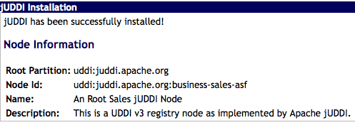
Figure 9.1 Sales Node Installation.
Setup Node 2: Marketing
cd juddiv3/WEB-INF/classes
mv RENAME4MARKETING_juddi_custom_install_data juddi_custom_install_data
edit: juddiv3.properties and set the following property values
juddi.server.name=marketing
juddi.server.port=8080
where 'marketing' is the dns name of your server. Start the server (tomcat), which will load the UDDI seed data (since this is the first time you're starting jUDDI, see Chapter 5)
bin/startup.sh
open your browser to http://marketing:8080/juddiv3. You should see

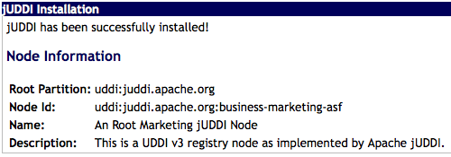
Figure 9.2 Marketing Node Installation.
Note that we kept the root partition the same as sales and marketing are in the same company, however the Node Id and Name are different and reflect that this node is in 'sales' or 'marketing'.
Finally you will need to edit the uddi-portlet.war/WEB-INF/classes/META_INF/uddi.xml and set the following properties:
<name>default-ws</name>
<properties>
<property name="serverName" value="sales"/>
<property name="serverPort" value="8080"/>
<property name="rmiPort" value="1099"/>
</properties>
Log into the sales portal: http://sales:8080/pluto with username/password: sales/sales.
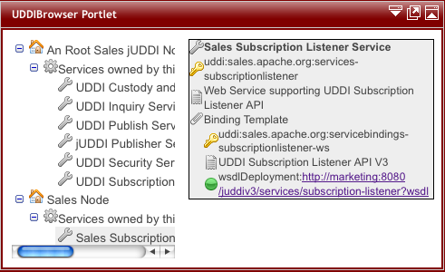
Figure 9.3 Sales Services.
Beforelogging into the markteting portal you will need to edit the uddi-portlet.war/WEB-INF/classes/META_INF/uddi.xml and set the following properties:
<name>default-ws</name>
<properties>
<property name="serverName" value="sales"/>
<property name="serverPort" value="8080"/>
<property name="rmiPort" value="1099"/>
</properties>
Now log into the marketing portal http://marketing:8080/pluto with username/password: marketing/ marketing. In the browser for the marketing node we should now see:
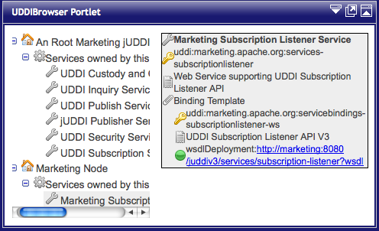
Figure 9.4. Marketing Services
Note that the subscriptionlistener is owned by the Marketing Node business (and not the Root Marketing Node). The Marketing Node Business is managed by the marketing publisher.

Deploy the HelloSales Service
The sales department developed a service called HelloSales. The HelloSales service is provided in the juddiv3-samples.war, and it is annotated so that it will auto-register. Before deploying the war, edit the juddiv3-samples.war/WEB-INF/classes/META-INF/uddi.xml file to set some property values to 'sales'.
<?xml version="1.0" encoding="ISO-8859-1" ?>
<uddi>
<reloadDelay>5000</reloadDelay>
<manager name="example-manager">
<nodes>
<node>
<name>default</name>
<description>Sales jUDDI node</description>
<properties>
<property name="serverName" value="sales"/>
<property name="serverPort" value="8080"/>
<property name="keyDomain" value="sales.apache.org"/>
<property name="department" value="sales" />
</properties>
<proxyTransport>org.apache.juddi.v3.client.transport.InVMTransport</proxyTransport>
<custodyTransferUrl>org.apache.juddi.api.impl.UDDICustodyTransferImpl</custodyTransferUrl>
<inquiryUrl>org.apache.juddi.api.impl.UDDIInquiryImpl</inquiryUrl>
<publishUrl>org.apache.juddi.api.impl.UDDIPublicationImpl</publishUrl>
<securityUrl>org.apache.juddi.api.impl.UDDISecurityImpl</securityUrl>
<subscriptionUrl>org.apache.juddi.api.impl.UDDISubscriptionImpl</subscriptionUrl>
<subscriptionListenerUrl>org.apache.juddi.api.impl.UDDISubscriptionListenerImpl</subscriptionListenerUrl>
<juddiApiUrl>org.apache.juddi.api.impl.JUDDIApiImpl</juddiApiUrl>
</node>
</nodes>
</manager>
</uddi>

Now deploy the juddiv3-samples.war to the sales registry node, by building the juddiv3-samples.ar and deploying. The HelloWorld service should deploy
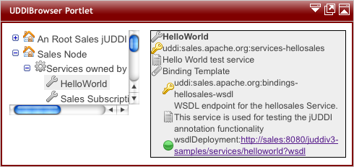
Figure 9.5. Registration by Annotation, deploying the juddi-samples.war to the sales Node.
On the Marketing UDDI we'd like to subscribe to the HelloWord service, in the Sales UDDI Node. As mentioned before there are two ways to do this; synchronously and asynchronously.

Configure a user to create Subscriptions
For a user to create and save subscriptions the publisher needs to have a valid login to both the sales and the marketing node. Also if the marketing publisher is going to create registry objects in the marketing node, the marketing publisher needs to own the sales keygenerator tModel. Check the marketing_*.xml files in the root seed data of both the marketing and sales node, if you want to learn more about this. It is important to understand that the 'marketing' publisher in the marketing registry owns the following tModels:
<save_tModel xmlns="urn:uddi-org:api_v3">
<tModel tModelKey="uddi:marketing.apache.org:keygenerator" xmlns="urn:uddi-org:api_v3">
<name>marketing-apache-org:keyGenerator</name>
<description>Marketing domain key generator</description>
<overviewDoc>
<overviewURL useType="text">
http://uddi.org/pubs/uddi_v3.htm#keyGen</overviewURL>
</overviewDoc>
<categoryBag>
<keyedReference tModelKey="uddi:uddi.org:categorization:types" keyName="uddi-org:types:keyGenerator"
keyValue="keyGenerator" />
</categoryBag>
</tModel>
<tModel tModelKey="uddi:marketing.apache.org:subscription:keygenerator" xmlns="urn:uddi-org:api_v3">
<name>marketing-apache-org:subscription:keyGenerator</name>
<description>Marketing Subscriptions domain key generator</description>
<overviewDoc>
<overviewURL useType="text">
http://uddi.org/pubs/uddi_v3.htm#keyGen</overviewURL>
</overviewDoc>
<categoryBag>
<keyedReference tModelKey="uddi:uddi.org:categorization:types" keyName="uddi-org:types:keyGenerator"
keyValue="keyGenerator" />
</categoryBag>
</tModel>
<tModel tModelKey="uddi:sales.apache.org:keygenerator" xmlns="urn:uddi-org:api_v3">
<name>sales-apache-org:keyGenerator</name>
<description>Sales Root domain key generator</description>
<overviewDoc>
<overviewURL useType="text">
http://uddi.org/pubs/uddi_v3.htm#keyGen</overviewURL>
</overviewDoc>
<categoryBag>
<keyedReference tModelKey="uddi:uddi.org:categorization:types" keyName="uddi-org:types:keyGenerator"
keyValue="keyGenerator" />
</categoryBag>
</tModel>
</save_tModel>

If we are going to user the marketing publisher to subscribe to updates in the sales registry, then we need to provide this publisher with two clerks in the uddi.xml of the uddi-portlet.war.
<clerks registerOnStartup="false">
<clerk name="MarketingCratchit" node="default-ws" publisher="marketing" password="marketing"/>
<clerk name="SalesCratchit" node="sales-ws" publisher="marketing" password="marketing"/>
<!-- optional
<xregister>
<servicebinding entityKey="uddi:marketing.apache.org:servicebindings-subscriptionlistener-ws" fromClerk="MarketingCratchit" toClerk="SalesCratchit"/>
</xregister>
-->
</clerks>

Here we created two clerks for this publisher called 'MarketingCratchit' and 'SalesCratchit'. This will allow the publisher to check the existing subscriptions owned by this publisher in each of the two systems.

Synchronous notifications
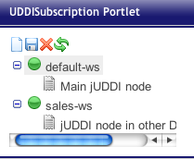
While being logged in as the marketing publisher on the marketing portal, we should see the following when selecting the UDDISubscription Portlet.
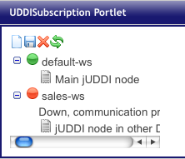
Figure 9.6. Subscriptions. In (a) both nodes are up while in (b) the sales node is down.
When both nodes came up green you can lick on the 'new subscription' icon in the toolbar. Since we are going to use this subscription synchronously only the Binding Key and Notification Interval should be left blank, as shown in figure 9.7. Click the save icon to save the subscription.
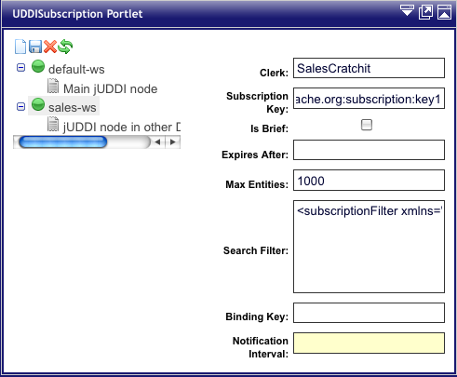
Figure 9.7. Create a new subscription.
Make sure that the subscription Key uses the convention of the keyGenerator of the marketing publisher. You should see the orange subscription icon appear under the “sales-ws” UDDI node.
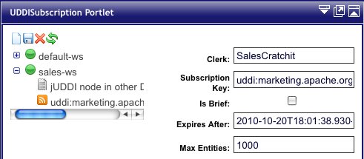
Figure 9.8 A newly saved subscription.
To invoke a synchronous subscription, click the icon with the green arrows. This will give you the opportunity to set the coverage period.
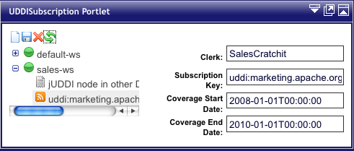
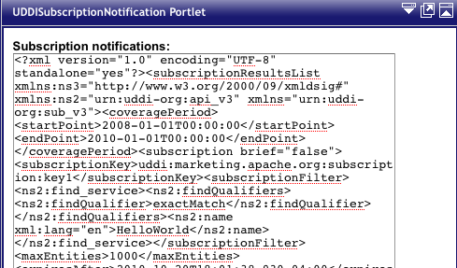
Figure 9.9 Set the coverage period.
Click the green arrows icon again to invoke the synchronous subscription request. The example finder request will go out to the sales node and look for updates on the HelloWorld service. The raw XML response will be posted in the UDDISubscriptionNotification Portlet

Figure 9.10. The Raw XML response of the synchronous Subscription request.

The response will also be consumed by the marketing node. The marketing node will import the HelloWorld subscription information, as well as the sales business. So after a successful sync you should now see three businesses in the Browser Portlet of the marketing node, see figure 9.11.

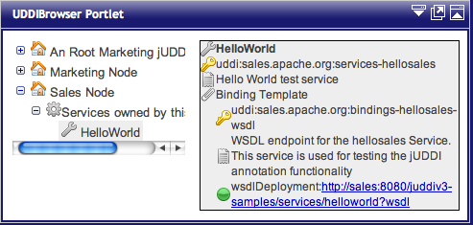
Figure 9.11. The registry info of the HelloWorld Service information was imported by the subscription mechanism.

Administration

Introduction
General Stuff about administration.

Changing the listener port
If you want to change the port Tomcat listens on to something non-standard (something other than 8080):
- edit conf/server.xml and change the port within the <Connector> element
- edit webapps/uddi-portlets/WEB-INF/classes/uddi.properties and change the port numbers within the endpoint URLs
- edit webapps/juddi/WEB-INF/classes/juddi.properties and change the port number
- edit pluto/WEB-INF/classes/server.xml and change the port within the <Connector> element

References

[UDDI] uddi xml.org – Online community for the Universal Description, Discovery, and Intergration OASIS Standard. http://uddi.xml.org
[COM-CONFIG] Apache Commons Configuration Project http://commons.apache.org/configuration/
Index

