Apache JMeter proxy Step-by-step

This tutorial attempts to explain the exact steps for JMeter's proxy. For those new to JMeter, one easy way to create a test plan is to use the Proxy. What the proxy does is it records the requests sent to the server.

Basic Proxy Instructions

- Go to JMETER_HOME/bin and start JMeter with jmeterw.cmd on Windows and jmeter on Linux/Unix
- Select “Test Plan” on the tree
- Right click on the “Test Plan” and add a new thread group: Add > Threads (Users) > Thread Group
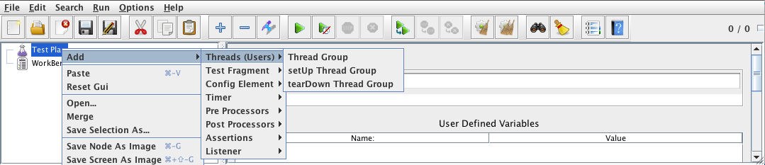
- Select the Thread Group
- Right click “Add -> Config Element -> HTTP Request Defaults”
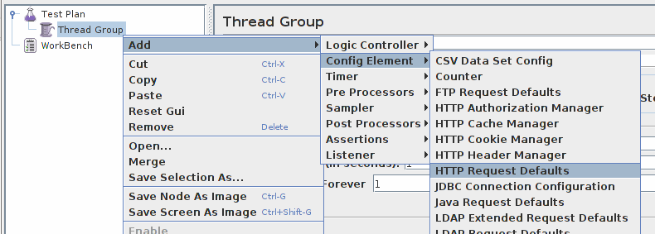
- In new HTTP Request Defaults element: Server name – enter “jmeter.apache.org”
- Path – leave blank
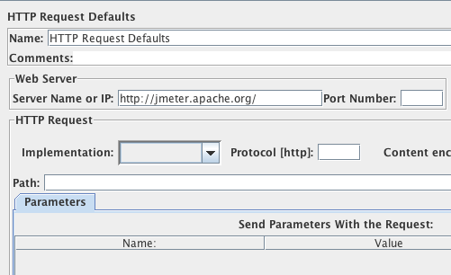
- Right click on the “Thread Group” and add a recording controller: Add > Logic Controller > Recording Controller
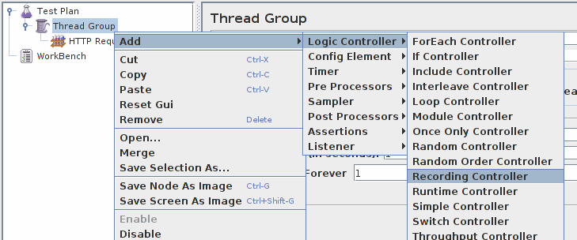
- Next, select WorkBench
- Right click on WorkBench and add the Http proxy: Add -> Non-Test Elements -> HTTP Proxy Server
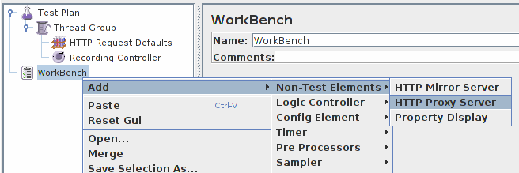
- On HTTP Proxy Server, click the “Add” button in “URL Patterns to Include”. This will create a blank entry.
- Enter “.*\.html”
- Click 3 times, the “Add” button in “URL Patterns to Exclude”. This will create 3 blank entries.
- Enter “.*\.png” pattern, “.*\.gif” pattern and “.*\.ico” pattern
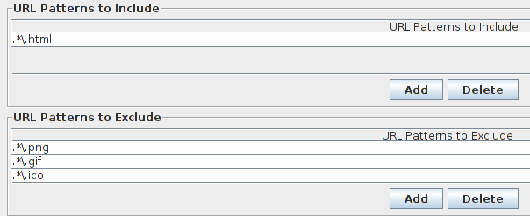

- Right click on “HTTP Proxy Server” and add a listener: Add -> Listener -> View Results Tree
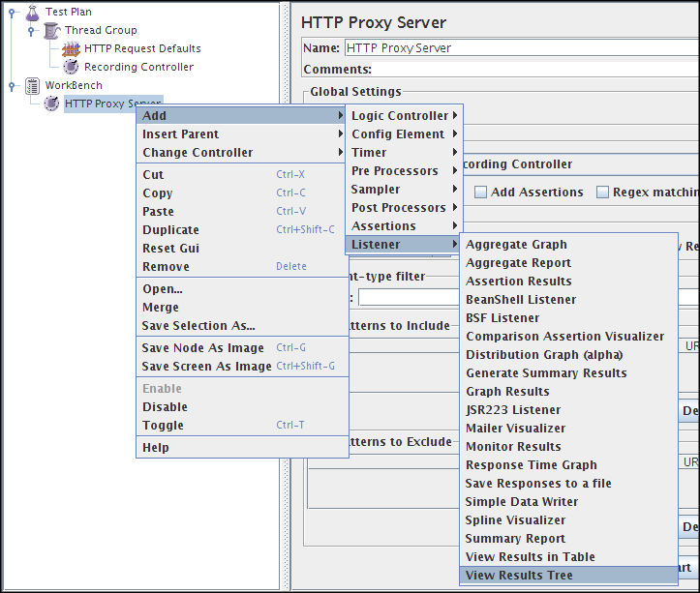
- Return to HTTP Proxy Server, and click the “Start” button at the bottom
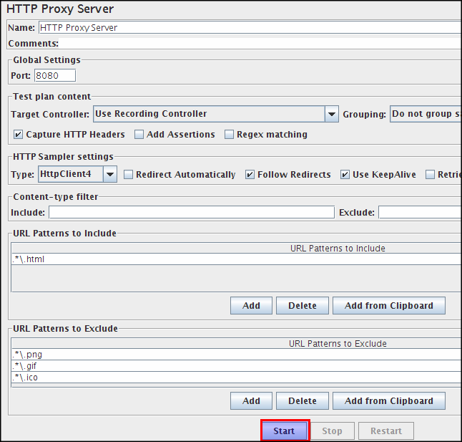

Configure your brower to use the JMeter HTTP Proxy
At this point, JMeter's proxy is running. For this exercise, we will use Iceweasel/Firefox to view some pages on JMeter.
- Start Iceweasel/Firefox, but do not close JMeter.
- From the tool bar, click “Edit -> Preferences” (or “Tools > Preferences”). This should bring up the options.
- Select the “Advanced” tab, and “Network” tab
- Click “Settings” button near the bottom.
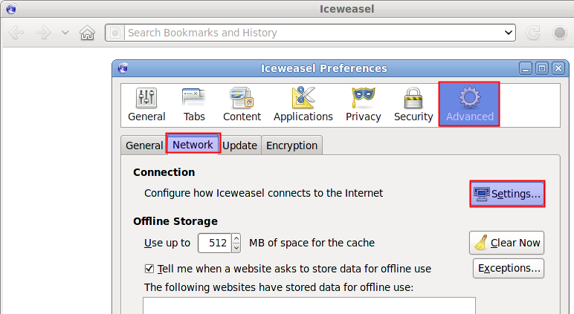
- On the new popup, check “Manual proxy configuration”. The address and port fields should be enabled now.
- Address – enter “localhost” or the IP address of your system
- Port – enter “8080”.
- Check “Use this proxy server for all protocols”
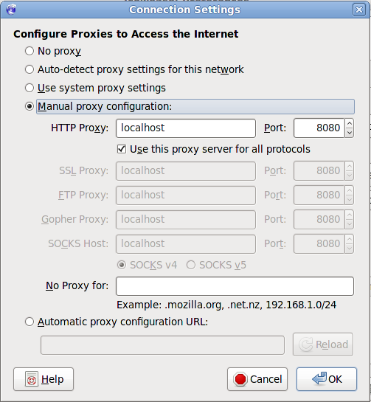
- Click “ok” button
- Click “ok” button again. This should return you to the browser

Record your navigation
- With your brower, in the “Address” bar at the top, enter “http://jmeter.apache.org/index.html” and hit the “enter” key.
- Click on a few links on JMeter's pages.
- Close your browser and bring up the JMeter window.

Expand the thread group and there should be several samplers. At this point, the test plan can be saved as is. If you forget to add default http request settings, you will have to manually delete the server name, and port.
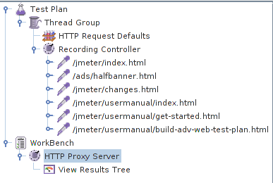

In this sample, there aren't any default request parameters. If a particular request parameter is required by all pages, the request defaults is where one would add the entries.
- Select “Thread Group”
- Right click “Add -> Listener -> Summary Report” to add an summary listener.

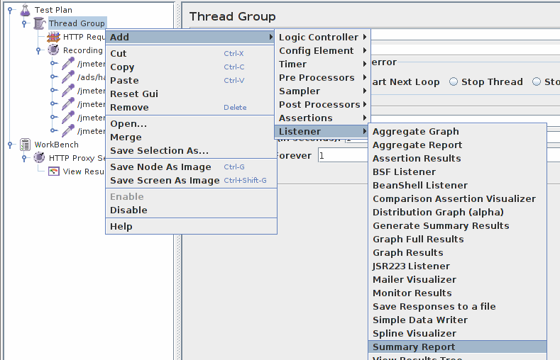
- The summary listener will show some basic statistics.
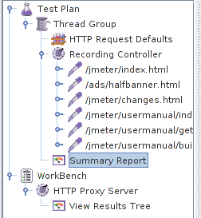
- Select “Thread Group”
- Number of Threads – enter “5”
- Ramp up Period – do not change
- Loop Count – enter 100

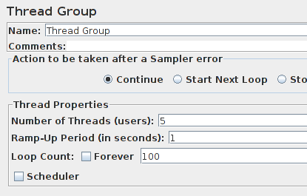

Start the test
At this point, we are ready to run our test plan and see what happens. Save the test plan. When you're ready to run the test, there's two ways:

- Run -> Start
- Ctrl–R

Before you start the test, select “Summary Report”. As the test runs, the statistics will change until the test is done. At the end of the test, the summary report should look like this.

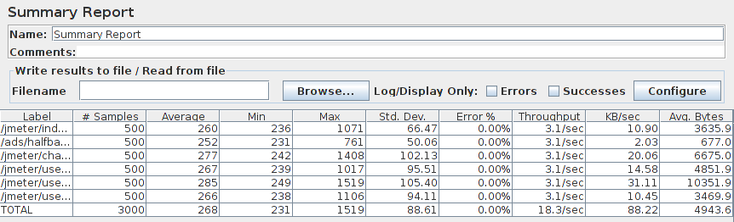

While the test is running, in the upper right-hand corner, there should be a green square. When the test is done, the box should be grey.



